Guide to Environmental Management for Textiles

A key requirement of the Global Organic Textile Standard (GOTS) is that all licensed companies have an environmental management policy or plan. This policy also needs to be implemented by any sub-contractors or additional facilities, and must cover all aspects of production – not just GOTS certified products. Ensure you have referred to GOTS V7 to comply with the requirements.

4.3.1 Environmental management policy
All companies must assure compliance with the applicable national and local legal environmental requirements applicable to their processing/manufacturing stages performed (including those referring to emissions to air, wastewater discharge as well as disposal of waste and sludge).
They must have a written environmental policy and procedures in place to allow monitoring and improving relevant environmental performances in their facilities. Depending on the processing/manufacturing stages performed, the available data and procedures need to include:
a. Responsible person(s) for environment and chemical management related duties
b. Data on energy and water resources and their consumption per kg of textile output
c. Target goals and procedures to reduce energy and water consumption per kg of textile output
d. Target goals and procedures to increase the use of renewable sources of energy
e. Data on waste and discharges per kg of textile output
f. Target goal and procedures to minimise waste and discharges
g. Procedures to follow in case of waste and pollution incidents
h. Documented staff training for topics such as conservation of resources such as water, energy, proper handling, responsible use and correct disposal of chemicals.
i. Long-term and short-term projects for improvement

4.3.1.5 Wet processing units shall keep full records of chemical, energy, and water consumption as
well as wastewater treatment data, including the disposal of sludge. Certified Entities shall
continuously measure and monitor wastewater temperature, wastewater pH, sediment
quantities, and waste toxicity.

Utilities consumed in processing mills are:
• Electricity
• Heating Energy
• Water

Utilities are consumed in a textile mill both during processing and for purposes outside processing, like office heating, lighting etc.

Water is mainly consumed during wet processing (dye house), during finishing in padders, for chemicals and dye stuffs dispensing, in boilers for steam production, and for non process-related purposes (floor cleaning, machine cleaning, wash rooms etc). Water is discharged into an effluent treatment facility; in some cases water is purified and recovered through reverse osmosis and filtering techniques.

Electricity is consumed by ALL machines and for lighting purposes etc. It may either be sourced from the grid or may be produced in the course of a co-generation process by a steam or a gas turbine. Electricity from renewable energy sources (windmills, PV, biomass) is increasingly available to industrial facilities.

Heating energy is consumed to generate steam (which is mainly consumed during wet processing) and by some finishing machinery. Heating energy is also required to heat finishing machinery directly (not via steam) such as stenters, driers etc. Also heating energy recovery systems may be in place recovering a substantial portion of the heat emitted in the form of hot exhaust gases.

Below table depicts the activities to which the utilities consumption can be typically
allocated to in a dyeing/ finishing mill:

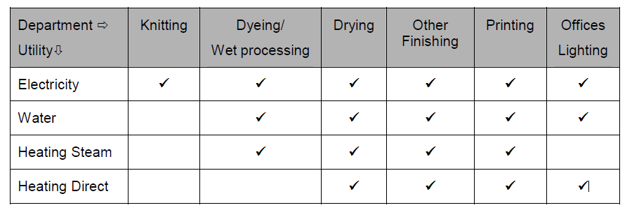

Possibilities to monitor Water and Energy Consumptions

Heating energy sources are typically:
• Oil (heating oil, bunker oil etc.)
• LNG, LPG
• Coal
• Husk, Wood pellets, Wood etc.

In some cases, steam is being sourced directly by central steam producers (typically in industrial districts).

The consumption of heating energy can thus be easily monitored by looking at purchasing invoices (for husk, wood pellets, oil 5) or bills (LNG, sourced steam 5). Electricity is either supplied from the grid or is co-generated whereby some kind of fuel is used to run a turbine (and in most cases also steam is produced for the production process). In the case of receiving power supply from the grid, the monitoring of consumption can be done by looking into the bills. In the case of cogeneration, the monitoring becomes slightly more complicated. Since excess cogenerated power can also be sold to the grid at times it is not consumed by the mill, one needs to find out the net consumed electricity by adding to the produced electrical energy from the turbine the electrical energy sourced from the grid in the same period and subtracting the electrical energy sold to the grid operator in the same period. In the case of co-generation, it is also important to understand how much fuel was consumed to produce energy and how much was consumed by the process (in the form of steam or direct heating). So, in this case the analysis will require more data, but since co-generation typically involves commercial transactions with a utilities company the required documentation will always be available in the form of bills and official invoices.

Also, electricity generation from renewable energy sources (photo voltaic, wind turbines etc) involves the same principle of excess power being sold to the grid and whenever produced power is insufficient sourcing power from the grid. Hence, again there will be official documents showing how much electric energy was sold to the grid and how much was sourced, whereas there will always be a meter documenting how much electric energy was actually produced by the Renewable Energy System.

Water monitoring is not as straightforward, especially in cases where the water is pumped out of a bore hole (or from nearby reservoirs like lakes, rivers etc). In such cases monitoring of water quantities pumped to the mill can only be monitored through a metering device mounted in the main pipeline out of the bore hole. No other technical possibility would allow accurate recording of consumed water quantities.

Alternatively, one could use metering devices mounted on the pipeline immediately before the Effluent Treatment Plant, however this reading will only show how much water ends up to the ETP (for example it will not include losses in form of steam etc). In case water is also (or exclusively) sourced from a supplying company, bills will show how much water has been sourced in each period. However, to account for pumped water from a bore hole (or nearby water reservoirs like lakes, rivers etc) the only credible means to monitor will be a metering device in the main pipeline to the mill.

Below table lists the recommended monitoring tools for each utility consumption:

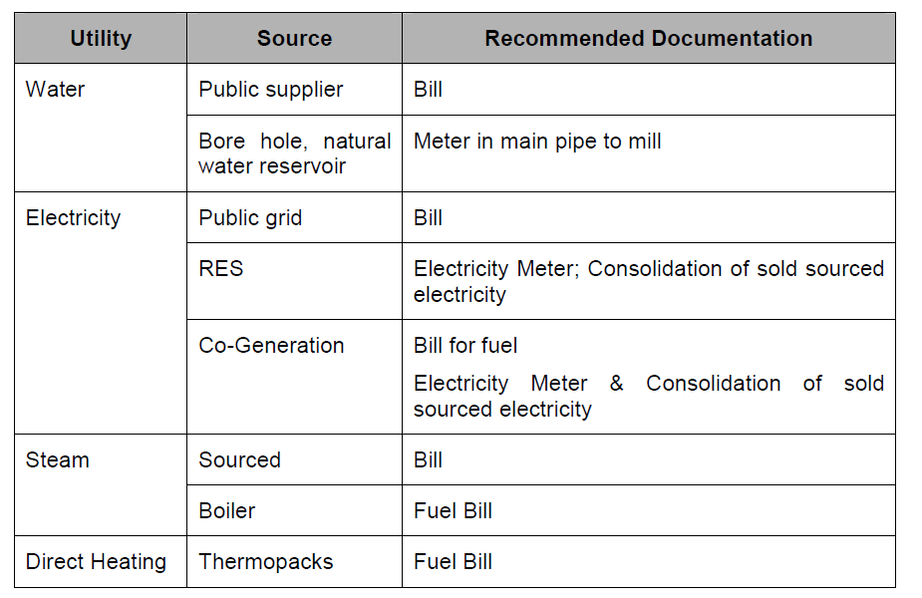

Wastewater Management (4.3.2)

To improve on water consumption a factory needs to look at the following:
• Technology (machines) used and investigate if there is better technology available, which allows shorter liquor ratios.
• Dye methods applied (and specifically investigate if some fill-drains can be omitted or merged with others, if washing times can be shortened etc.)
• Used dyes and Chemicals
In addition to these in-cycle interventions the factory needs to also:
• Control/ minimize re-processing
• Minimize the number of machines cleaning cycles

There is no generic way to address all these. Many of the above (especially reprocesses and cleaning cycles) are a symptom rather than a prime cause, reflecting several operational mal-functions. Therefore, each factory needs to come to a custom-made solution, suitable for its own operational and organizational characteristics. An important feature, however, of any solution is that it will have to be reached through an optimization process at several levels simultaneously.

On the GOTS website is a downloadable tool to help with monitoring water and energy use.
Other areas to consider:
- 4.3.1.6 Noise pollution – in accordance with legal regulations and periodic testing carried out
- 4.3.1.6 Air pollution - in accordance with legal regulations and periodic testing carried out
- 4.3.1.7 Greenhouse Gas (GHG) emissions – identification of sources is required as well as monitoring, quantifying, and setting measures to reduce them.
- 2.6.1.4 Transportation means
- 4.3.1.4 Chemical inputs shall be maintained

Office based operations

If you are not directly involved with manufacturing you are still required to have an environmental management policy, although obviously it will bedifferent to one for a manufacturer. Areas your plan could consider:

- Monitoring, quantifying, and setting measures to reduce GHG emissions.
- Transport routes and means of the shipped goods with the related impacts; transportation means must be documented and maintained for inspection.
- Under which circumstances goods are produced starting from materials and accessories used.
- Processors and manufacturers assigned up to the packaging used for the products they purchase.
- Aiming to increase the volume of environmentally friendly manufactured (e.g. GOTS certified) textiles over time.
- Energy saving electrical devices, water saving devices in toilets, efficiency of insulation and heating systems, using renewable energy.
- Targets to minimise waste in sampling, transportation or office functions.
- Targets to design with consideration to end of life of GOTS goods e.g circular design.
- Degrowth planning.
- Using deadstock and offcuts from production.
- Increasing transparency of supply chains.

