Global Organic Textile Standard requirement:
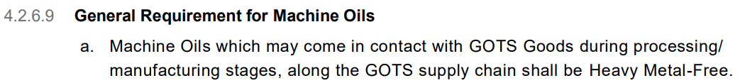

Global Organic Textile Standard definitions:
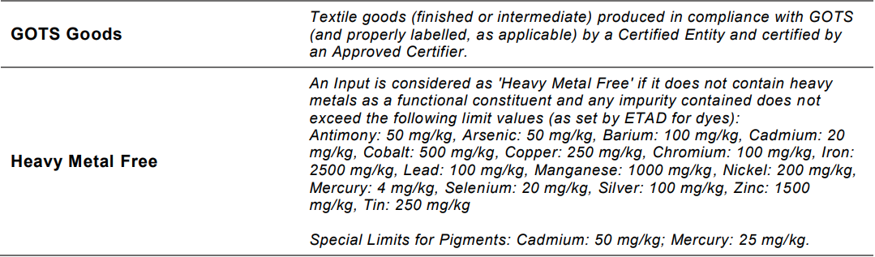

Purpose of this form:
Since v7.0 of the standard, the element of risk can be taken into consideration in certification decisions.

Please review your systems (whether the oil is heavy metal free, whether it could ever come into contact with GOTS Goods, what mitigation measures you have in place to avoid contamination, and whether those measures are effective) and submit details of your risk assessment using the template below.

Please complete one form per oil and per machine and submit a new form to fashion.textiles@soilassociation.org whenever there is an update.

We will then review your assessment of risk and communicate next steps.

About the machine
Machine name | Click or tap here to enter the machine name.
Describe what the machine does | Click or tap here to enter the function of the machinery.

About the machine oil
Oil name | Click or tap here to enter the oil name.
Purpose of oil | Click or tap here to enter the function of the oil.

Review
Oil applied to which part(s) of machine | Click or tap here to enter the position(s) of the oil in the machinery.
I confirm we have carried out a review to determine whether the machine oil named on page 1 could come into contact with GOTS Goods.

As a result of our review, we conclude that

☐ the machine is used for weaving, spinning, sewing, embroidery, or knitting (attachment 1 or attachments 2 + 3 required)

☐ the machine oil is intended to come into contact with GOTS Goods (attachment 1 or attachments 2 + 3 required)

☐ the machine oil could possibly come into contact with GOTS Goods unintentionally (e.g. leak)

☐ we conclude that GOTS Goods could not be contaminated with heavy metals whilst the product is under our control because the machine oil is heavy metal free (attachment 1 or attachments 2 + 3 required)

☐ we conclude that GOTS Goods could not be contaminated with heavy metals whilst the product is under our control because:
Click or tap here to enter all the reasons why you believe you have effective measures in place to prevent machine oils from contaminating of GOTS Goods.

☐ other: Click or tap here to enter text.

Attachments | ☐ 1- we have enclosed a copy of the oil’s GOTS Letter of Approval which demonstrates it meets the standard’s requirement  ☐ 2- we have enclosed a copy of the oil’s SDS which shows there are no functional heavy metals within the oil  ☐ 3- we have enclosed a copy of the oil’s heavy metal analysis, demonstrating that all substances listed on page 1 were tested, and they do not exceed the limits set by the standard  ☐ 4- we have enclosed photographic or diagrammatic evidence to support our assessment
Name & position | Click or tap here to enter your name and role within the organisation.
Company name | Click or tap here to enter your company name.
Today’s date | Click or tap to enter a date.

