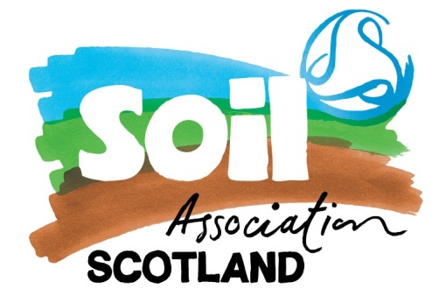
Field Lab: All Over Clover
Mossgiel Farm Plan

Story so far
220 acre dairy farm with a herd of Ayrshire cows (and 20 acres Barley contract), now certified organic with SOPA. Bryce took over the family farm a few years ago. He is working to turn it around from a position where it was financially insecure and reliant on expensive inputs, to an organic farm that sells direct to small businesses and customers, employs more people and is environmentally sustainable. They pasteurize their own milk on site, bottle and deliver it. Some goes to local cheese production. They also produce rose beef. They have issues with waterlogging & compaction, bare patches of soil, poaching, and rushes in some fields. Many of fields have been heavily slurried in the past.

Field Lab overview
Exploring grass seed mixes and grazing systems for dairy

At the kick-off Field Lab meeting in February we had a broad ranging discussion about the challenges of finding the right herbal leys that suit wet Ayrshire climate and how best to seed a new grass/herbal mix without adding to compaction. Suggestion raised to bring in sheep to tightly graze before reseeding, and we also discussed the value of aerating and liming versus keeping tractors off the field altogether to prevent further compaction.

Since then farmer Bryce Cunningham has undertaken 6 days of intensive on-farm training in Holistic Management with consultants from 3LM. This has led to a rethink of the grazing system on the farm and how to transition to a different way of farming that builds towards sustained profitability, healthy social relationships, thriving soil and ecosystems. Bryce has said:

“What we’re doing today is for 5 years down the line, it all goes back to financial planning and your own holistic context, so no two grazing plans will be the same. It’s all about the principle of rest and moving animals at the right time. We’ll be slightly overstocked for the first year of holistic management plan but at the end of 3 years we hope to be able to carry 3 times the number of stock on the same land. Water cycle is our main challenge on the farm.”

Holistic Management is a process of decision-making and planning that gives people the insights and management tools needed to work with nature; resulting in better, more informed decisions that balance economic, social and environmental considerations. In the context of the ecological restoration of grasslands, managers implement Holistic Planned Grazing to properly manage livestock — mimicking the predator/prey relationships in which these environments evolved.
Bryce has divided the farm into two different sections:
North Platform (north facing) – milkers, bulling heifers & bull
South Platform (south facing) – all young stock & dry cows

The Field Lab trial will be carried out in a field from each section to compare the North and South facing aspects on the farm.

Aims to:
- Improve grazing season length / reduced poaching
- Improve grass yield – dry matter
- Improve grass & silage quality
- Reduce sodium chloride – making potash and phosphorus more available
- Improve water cycles – less run off / waterlogging

TIMELINE

Timeline | Actions to trial fields | Field Lab Meeting
Feb |  | Field Lab meeting 6th Feb
Mar | Behind schedule due to late Spring
Apr | Limed & dunged with Farm yard manure (well composted mix of straw, manure, coffee grounds & fresh grass)  Soil analysis taken 24/4/18 | Field Lab meeting postponed due to poor weather
May | Grazed hard with young stock  Oversown on 29th May with 2 mixes:  - Herbal ley with diploid grasses & white clover  - More standard rye grass and clover mix
Jun | Rest | Field Lab meeting 12th June  Assess grass and new grazing method
Jul | Take silage cut or divide into 5 cells and graze it. All based on observation of weather, temp & growth rate. Ideally will graze rather than cut silage.
Aug | Rest | Meeting tbc
Sep | Graze again if conditions right

Data collection:

- Routine soil analysis (April 2018)
- Scoring grass out of 5 – grass growth, poaching
- Photos of quadrant - % of bare soil, grass species diversity
- Plate meter readings to measure dry matter
- Silage analysis

